**WAD EXERCISES:-**

**Exercise-1**

**Create a simple html page using basic tags.**

<!Doctype html>

<html>

<head>

<title>My Pagee</title>

</head>

<body>

<h1>My first heading</h1>

<p>My first paragraph.</p>

<a href="https://www.google.com/">here is the link </a>

</body>

</html>

**OUTPUT:**

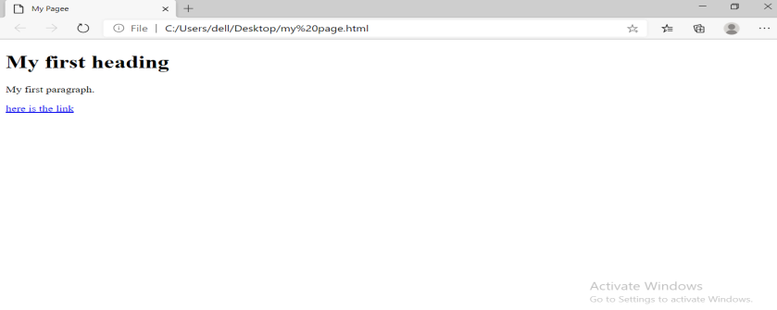

**Exercise-2**

**Create a webpage that displays your name to the screen.**

<!Doctype html>

<html>

<head

<title>Display Name</title>

</head>

<body>

<h1>Vedika kaushik</h1>

</body>

</html>

**OUTPUT:**

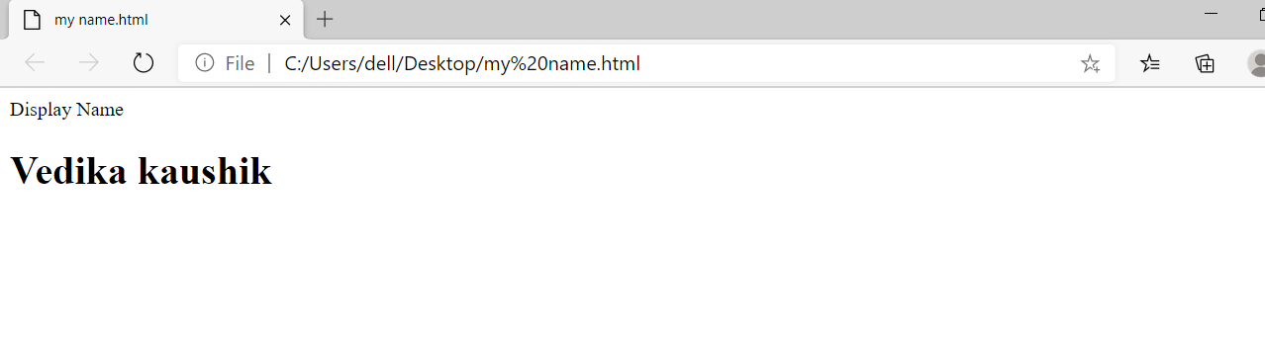

**Exercise-3**

**Create a webpage and show output from 1 to 10 in separate lines.**

<!Doctype html>

<html>

<head>

<title>Numbers 1 to 10</title>

</head>

<body>

<br>1</br>

<br>2</br>

<br>3</br>

<br>4</br>

<br>5</br>

<br>6</br>

<br>7</br>

<br>8</br>

<br>9</br>

<br>10</br>

</body>

</html>

**OUTPUT:**

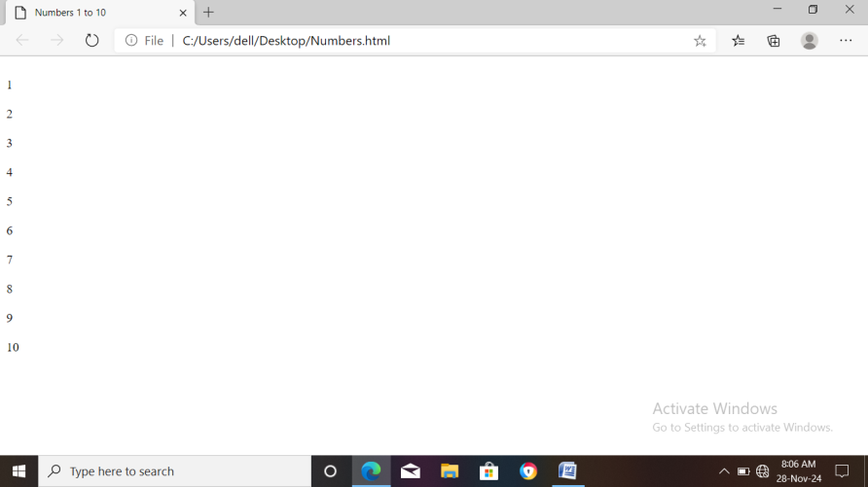

**Exercise-4**

**Create a webpage and show the output from 1 to 10 in separate lines, each number being in different color.**

<!DOCTYPE html>

<html>

<head>

<title>Coloured Numbers 1 to 10</title>

</head>

<body>

<p style="color:green;">1</p>

<p style="color:pink;">2</p>

<p style="color:yellow;">3</p>

<p style="color:blue;">4</p>

<p style="color:red;">5</p>

<p style="color:purple;">6</p>

<p style="color:orange;">7</p>

<p style="color:brown;">8</p>

<p style="color:aqua;">9</p>

<p style="color:maroon;">10</p>

</body>

</html>

**OUTPUT:**

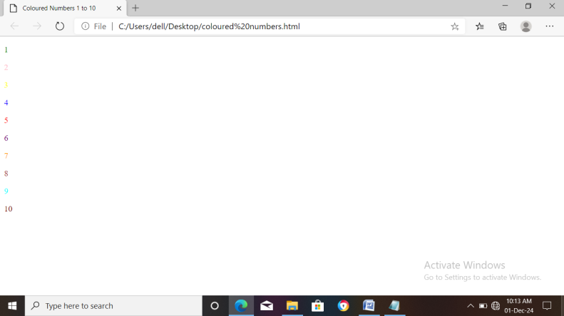

**Exercise-5**

**How do I make a picture as a background on my web page.**

<!DOCTYPE html>

<html>

<head>

<title>Image as a background</title>

</head>

<body>

<h1>Here is an image</h1>

<img src="C:\Users\PC18\Desktop\Nature.jpg"/>

<p>This is an image displayed on a background.</p>

</body>

</html>

**OUTPUT:**

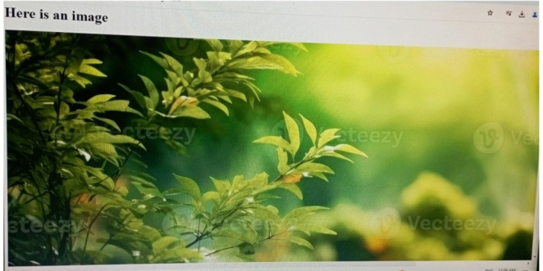

**Exercise-8**

**Write HTML code to print your name using Heading tag, every letter shall be of different heading size.**

<!DOCTYPE html>

<html>

<body>

<p><h1>V</h1> <h2>E</h2>

<h3>D</h3> <h4>I</h4>

<h5>K</h5> <h6>A</h6>

</body>

</html>

**OUTPUT:**

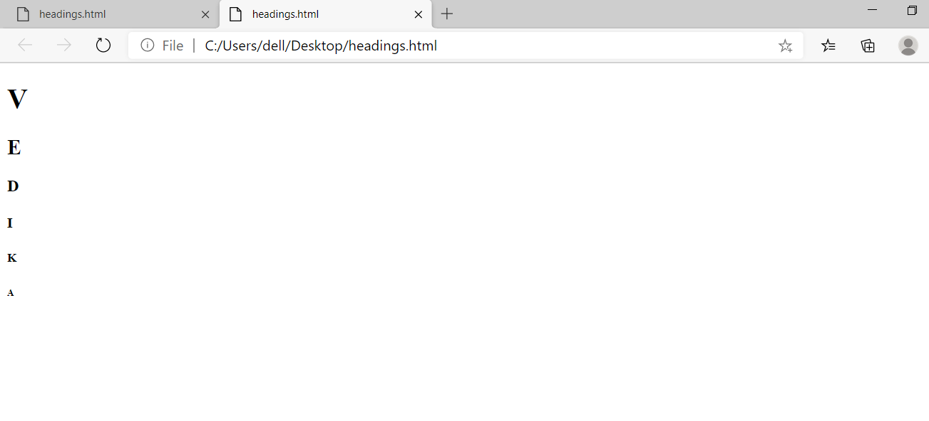

**Exercise-9**

**Write HTML code to print the sequence of numbers 1-20. Each number shall be in different line with number 2 next to its as subscript, an equal sign and the result.**

<!DOCTYPE html>

<html>

<body>

<p>1<sub>2</sub>=2<br>2<sub>2</sub>=4<br>

3<sub>2</sub>=6<br>4<sub>2</sub>=8<br>

5<sub>2</sub>=10<br>6<sub>2</sub>=12<br>

7<sub>2</sub>=14<br>8<sub>2</sub>=16<br>

9<sub>2</sub>=18<br>10<sub>2</sub>=20<br>

11<sub>2</sub>=22<br>12<sub>2</sub>=24<br>

13<sub>2</sub>=26<br>14<sub>2</sub>=28<br>

15<sub>2</sub>=30<br>16<sub>2</sub>=32<br>

17<sub>2</sub>=34<br>18<sub>2</sub>=36<br>

19<sub>2</sub>=38<br>20<sub>2</sub>=40

</body>

</html>

**OUTPUT:**

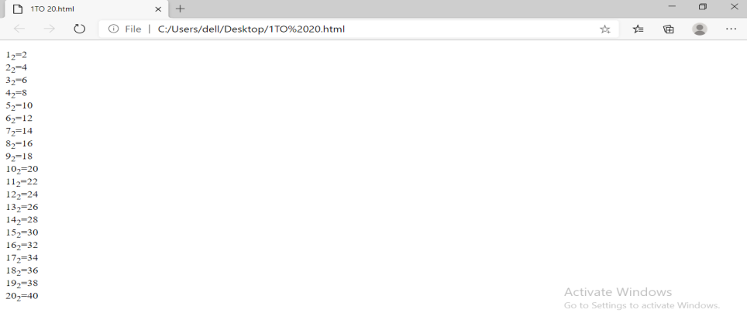

**Exercise-10**

**Write HTML code to display an image with border of size with width 200, height 200 pixels, leaving Hspace and Vspace of your choice with image hanging in the right side on the screen.**

<!DOCTYPE HTML>

<html>

<body> img src=”C:\Users\Vedika

Kaushik\Downloads\Snapinsta.app_275603135_106368588674571_292823

7324847993405_n_1080.jpg” alt=”insta” height=”200” width=

“200” hspace=”20” vspace=”20’ align=”right”>

</body>

</html>

**OUTPUT:**



**Exercise-11**

**Write a HTML code to create a web page with a heading. The heading shall be displayed at top center of the page and the image shall be at the center, just below the heading.**

<!DOCTYPE html>

<html>

<head><center>THE HEADING</center>

</head>

<title>heading</title>

<body>

<center>

<img src="C:\Users\VEDIKA

KAUSHIK\Downloads\krishna.png"align=center"

</center>

</body>

</html>

**OUTPUT:**

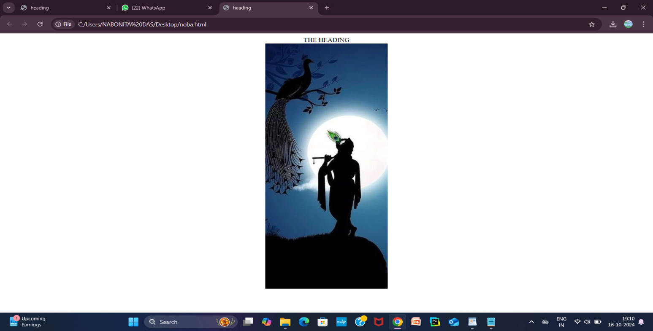

**Exercise-12**

**Write HTML code using multimedia tags.**

<!DOCTYPE html>

<html>

<head>

<title>VEDIKA</title>

</head>

<body>

<h1>Multimedia tags</h1>

Audio

<audio controls>

<source src="C:\Users\VEDIKA

KAUSHIK\Downloads\sms.mp3"type="audio/

mpeg">

</audio>

<br>

<p>Video</p>

<video width="320"height="240"

controls>

<source src="C:\Users\VEDIKA

KAUSHIK\Downloads\VIDEO.MP4"

type="video/mp4">

</video>

</body>

</html>

**OUTPUT:**

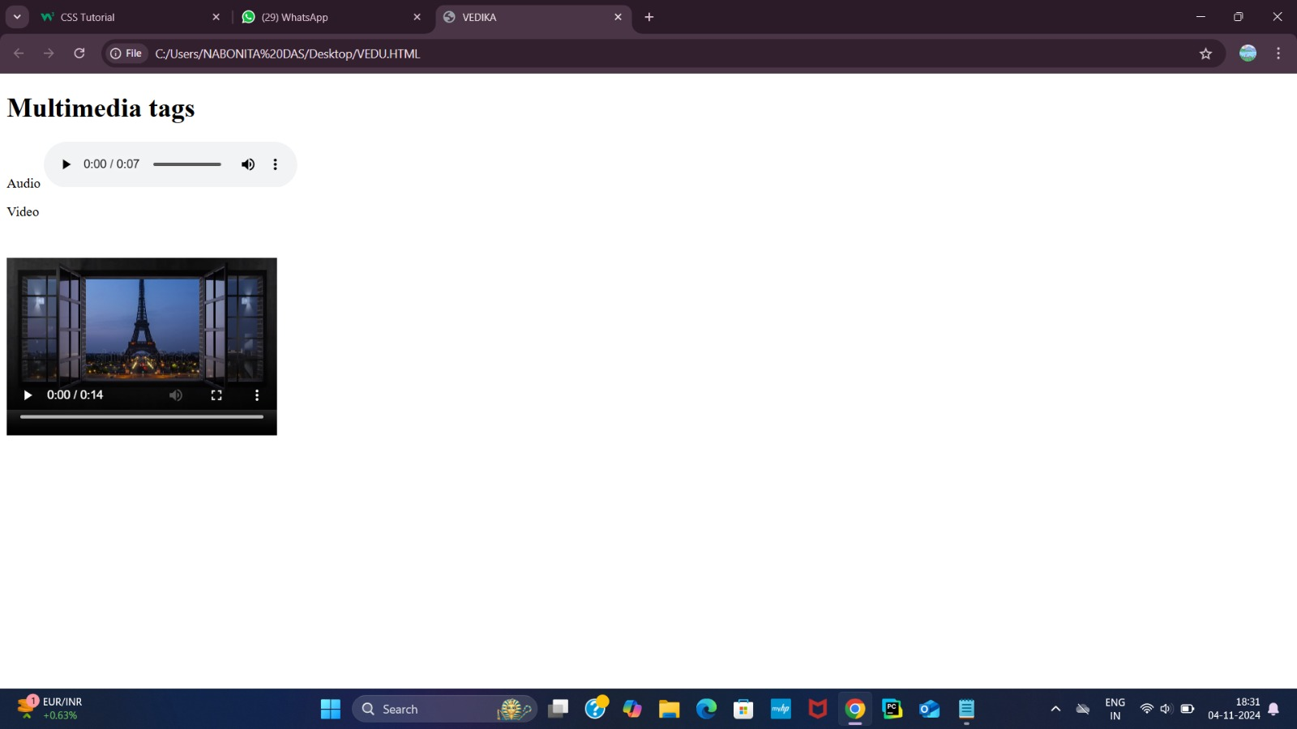

**Exercise-13**

**Create a table using rowspan and colspan taking examples of student records.**

!doctype html>

<html>

<head>

<title>Rowspan and colspan</title>

</head>

</body>

<h2>Student Marks</h2>

<table border="4">

<tr>

<th rowspan="2">Student Id</th>

<th rowspan="2">Name</th>

<th colspan="3">Subjects</th>

</tr>

<th>LAST</th>

<th>WAD</th>

<th>Python</th>

</tr>

<td>1</td>

<td>Vedika Kaushik</td>

<td>90</td>

<td>85</td>

<td>88</td>

</tr>

<tr>

<td>2</td>

<td>Diksha</td>

<td>86</td>

<td>81</td>

<td>90</td>

</tr>

<tr>

<td>3</td>

<td>Adidev</td>

<td>87</td>

<td>94</td>

<td>92</td>

</tr>

</table>

</body>

</html>

**OUTPUT:**

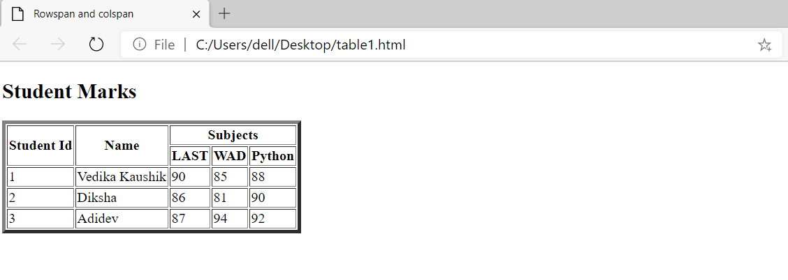

**Exercise-14**

**Write HTML code using table tag <table> and cell padding and cell spacing as its attributes.**

<!doctype html>

<html>

<head>

<title>table tags</title>

</head>

<body>

<h2>Student Marks</h2>

<table border="1"cellpaddin"10"cellspacing="5">

<tr>

<th>Student Id</th>

<th>Name</td>

<th>WAD</th>

<th>LAST</th>

<th>Python</th>

</tr>

<tr>

<td>1</td>

<td>Vedika kaushik</td>

<td>83</td>

<td>91</td>

<td>90</td>

</tr>

<tr>

<td>2</td>

<td>Diksha</td>

<td>80</td>

<td>89</td>

<td>85</td>

</tr>

<tr>

<td>3</td>

<td>Adidev</td>

<td>95</td>

<td>88</td>

<td>93</td>

</tr>

</table>

</body>

</html>

**OUTPUT :**

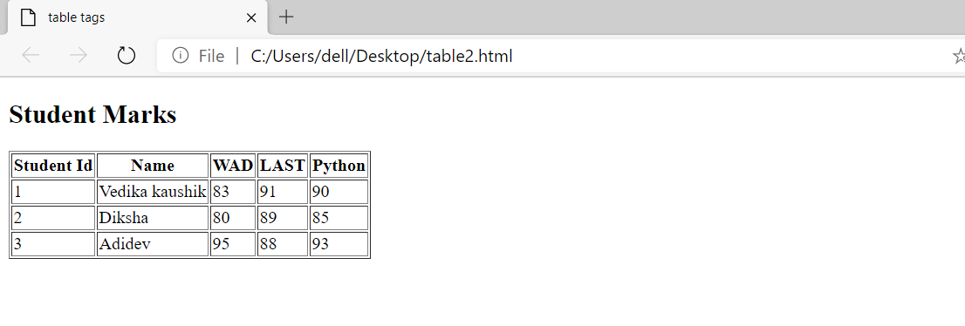

**Exercise-15**

**Write unordered, ordered and definition list taking example of your subjects in MCA 1st,2nd and 3rd semester.**

<!doctype html>

<html>

<head>

<title>MCA list</title>

</head>

<body>

<h1 style="color:blue;">MCA subjects</h1>

<h2>1st Semester Subjects</h2>

<ul>

<li>MathematicsI</li>

<li>Python Programming</li>

<li>Programming in C</li>

<li>Communication Skills</li>

</ul>

<h2>2nd Semester Subjects</h2>

<ol>

<li>MathematicsII</li>

<li>Data Structure</li>

<li>Database Management Systems </li>

<li>Operating System</li>

</ol>

<h2>3rd Semester</h2>

<dl>

<dt>Operating Systems:</dt>

<dd>Study of operating system concepts and structures</dd>

<dt>Web Technologies:</dt>

<dd>Introduction to web development and related technologies</dd>

<dt>Object-Oriented Programming:</dt>

<dd>Principles of OOPS using languages like Java</dd>

<dt>Computer Networks:</dt>

<dd>Overview of networking concepts and protocols</dd>

</dl>

</body>

</html>

**OUTPUT:**

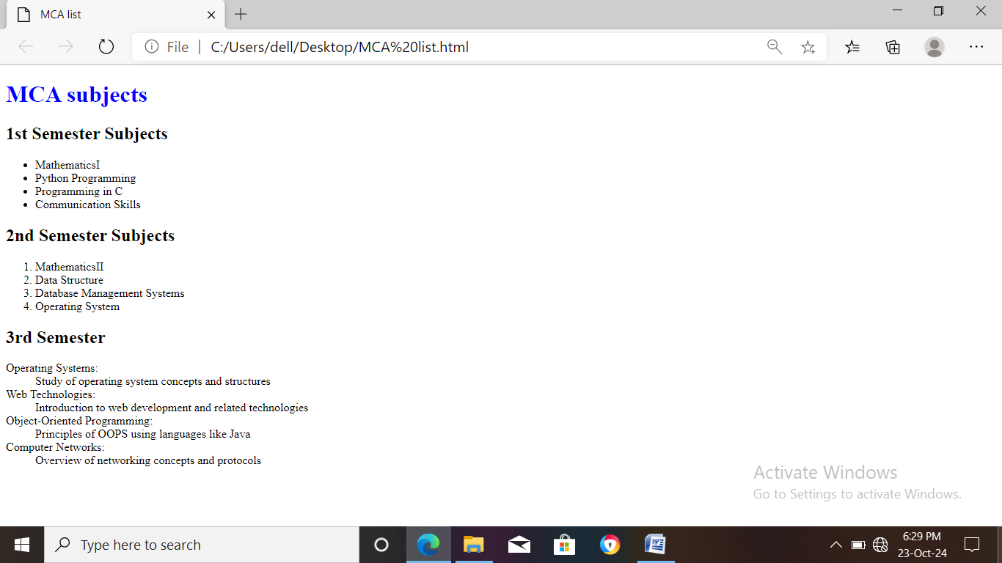

**Exercise-17**

**Write HTML code to design a form in HTML using controls and buttons such as Textbox, Textarea, Password, Submit button, browse button,drop-down menu.**

<!DOCTYPE html>

<html>

<head>

<title>password form</title>

</head>

<body>

<form action="/submit_form" method="post"><fieldset><legend>Login Page</legend>

<label for="username">Username:</label><br>

<input type="text" id="name" name="name"><br><br>

<label for="password">Password:</label><br>

<input type="password" id="password" name="password"><br><br>

<label for="leave a comments">Leave a Comments:</label><br>

<textarea id="other" name="comments" rows="4"cols="50"></textarea><br><br>

<label for="file">Upload a file:</label><br>

<input type="file" id="file" name="file"><br><br>

<label for="country">Country:</label><br>

<select id="country" name="country">

<option value="india">India</option>

<option value="us">United States</option>

<option value="uk">United Kingdom</option>

<option value="canada">Canada</option>

</select><br><br>

<input type="submit" value="Submit">

</form>

</body>

</html>

**OUTPUT:**

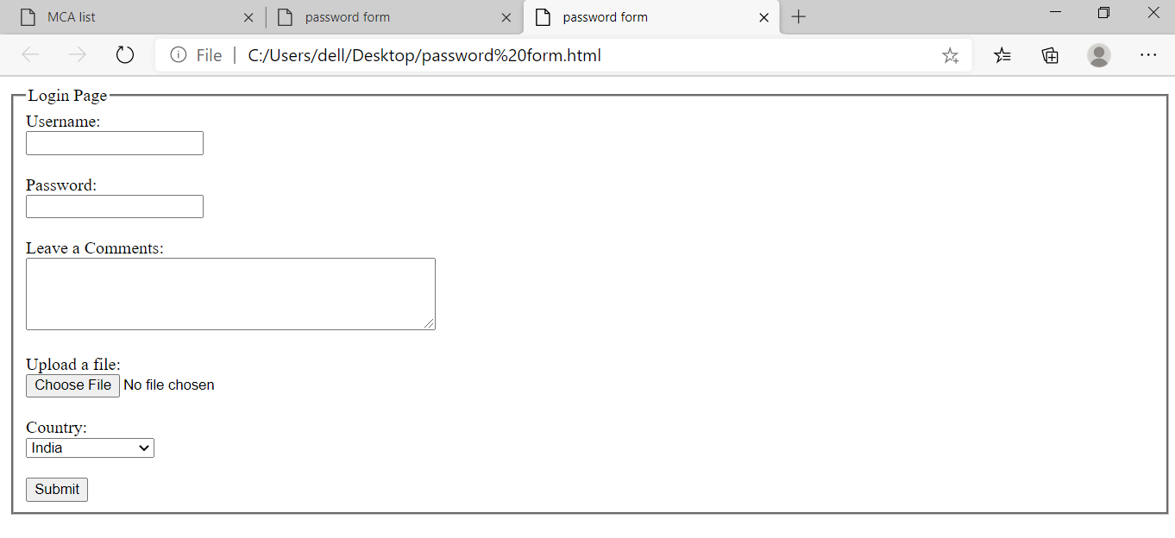

**Exercise-18&19**

**Write HTML code to design a Registration form in html.**

<!doctype html>

<html>

<head>

<title>Registration Form</title>

</head>

<body>

<h2 style="color:orange;"align="center">Registration Form</h2>

<form action="/submit_registration" method="post"><fieldset>

<label for="fname">First Name:</label>

<input type="text" id="fname" name="fname" required<br><br>

<label for="lname">Last Name:</label>

<input type="text" id="lname" name="lname" required><br><br>

<label for="email">Email:</label>

<input type="email" id="email" name="email" required><br><br>

<label for="password">Password:</label>

<input type="password"id="password" name="password" required><br><br>

<label for="gender">Gender:</label>

<select id="gender" name="gender">

<option value="male">Male</option>

<option value="female">Female</option>

<option value="other">Other</option>

</select><br><br>

<label for="bio">Bio:</label><br>

<textarea id="bio" name="bio" rows="4" cols="50"></textarea><br><br>

<label for="profilepic">Profile Picture:</label>

<input type="file" id="profilepic" name="profilepic"><br><br>

<label for="signature">Signature:</label>

<input type="file" id="sign" name="signature">

<center><button>Register</button>

<button>reset</button></center>

</form>

</body>

</html>

**OUTPUT:**

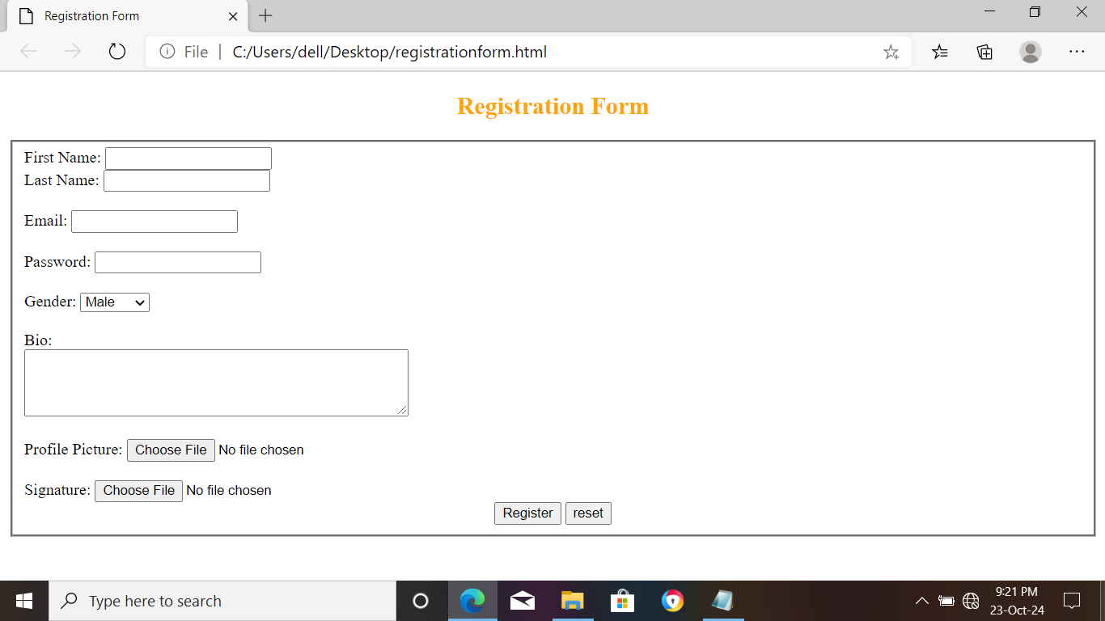

**Exercise-20**

**Create a proper home page of your own using any components and style.**

<!DOCTYPE html>

<html>

<head>

<title>My Homepage</title>

<link rel="stylesheet" href="C:\User\Vedika\Desktop\Bsc(IT)\html\body.css"></head>

<body>

<header>

<h1>Welcome to My Homepage</h1>

</header>

<p class="vedika">

<section class="about">

<h2>About Me</h2>

<p>Hello! I'm Vedika Kaushik currently pursing Bsc(IT).I have passion about singing .</p>

</section>

<section id="services">

<h2>Services</h2>

<p>The service I provide is HWCs.</p>

</section>

<section id="contact">

<h2>Contact Me</h2>

<p>You can reach me at kaushikvedika5@gmail.com.</p>

</section>

</body>

</html>

**OUTPUT:**

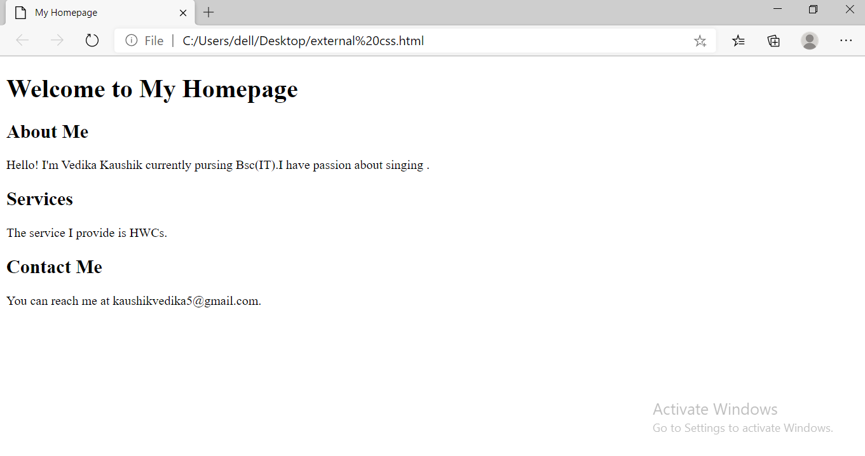

**Exercise-21**

**Write HTML code including local hyperlinking in a web page**

<!DOCTYPE html>

<html>

<head>

<title>Local Hyperlink Example</title>

</head>

<body>

<h1>Welcome to My Web Page</h1>

<p><a href="#section1">Go to Section 1</a></p>

<p><a href="#section2">Go to Section 2</a></P>

<h2 id="section1">Section 1</h2>

<p>This isthe content of Section 1.</p>

<p><a href="#top">Back to Top</a></p>

<h2 id="section2">Section 2</h2>

<p>This is the content of Section 2.</p.

<p><a href="#top">Back to Top</a></p>

</body>

</html>

**OUTPUT:**

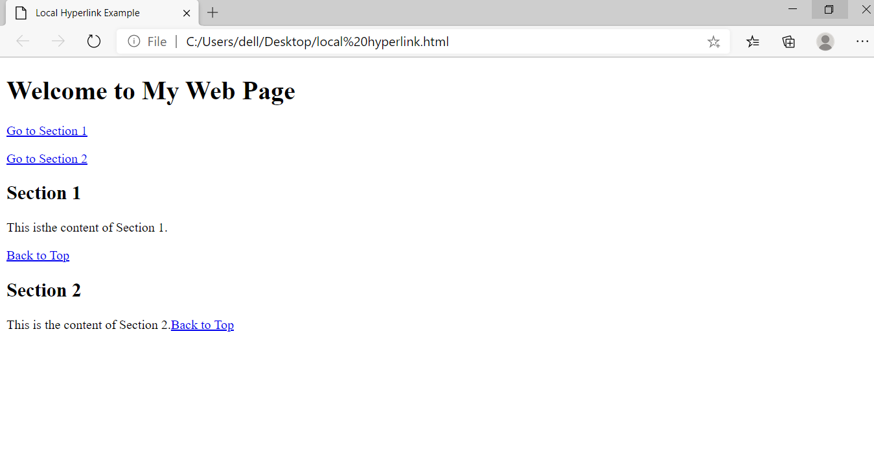

**Exercise-22**

**Write HTML code including inter hyperlinking in a web page.**

<!DOCTYPE html>

<html>

<head>

<title>Inter Hyperlink Example</title>

</head>

<body>

<h1>Welcome to My Web Page</h1>

<p><a href="https://www.youtube.com/watch?v=vPItsMdrhss">Visit this to listen Balkar

sidhu</a></p>

<p><a href="https://www.youtube.com/watch?v=xe5rCyGIfXc">Visit for Arjan Dhillon</a></p>

</body>

</html>

**OUTPUT:**

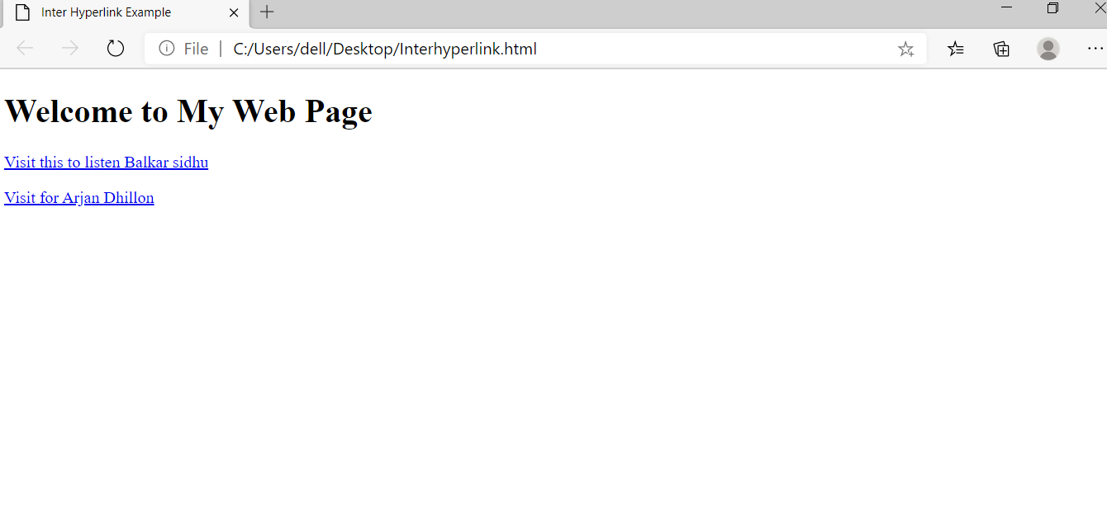

**Exercise-23**

**Write HTML code for including external hyperlinking in a web page.**

<!DOCTYPE html>

<html>

<head>

<title>External Hyperlink Example</title>

</head>

<body>

<h1>Welcome to My Web Page</h1>

<p>Check out this <a href="https://www.youtube.com/watch?v=rRShKY2PX4s"

target="_blank">exciting video</a></p>

</body>

</html>

**OUTPUT:**

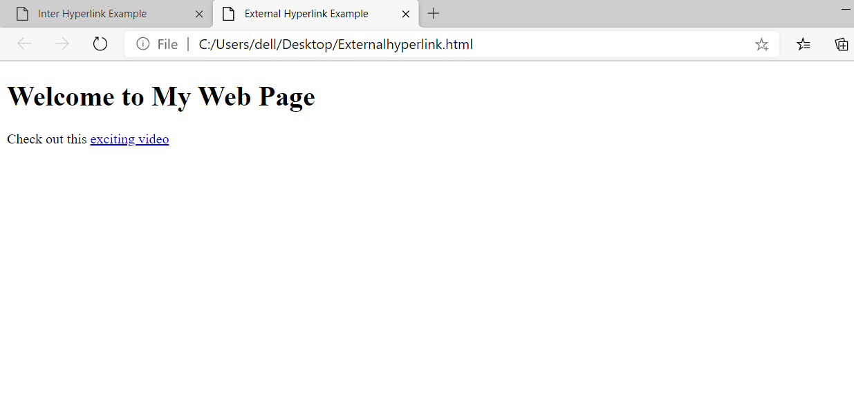

**Exercise-24**

**Write code to show External CSS with HTML code.**

<!DOCTYPE html>

<html>

<head>

<title>para</title>

<link rel=stylesheet href="C:\Users\vedika\OneDrive\Desktop\Bsc(IT)\CSS\stylesheet para.css">

</head>

<body>

<h1>This is para stylesheet with different id's</h1>

<p>CSS</p>

<p id="para1">This is para1</p>

<p id="para2">This is para2</p>

<p class="vedika">This is .vedika selector</p>

<h2>Vedika</h2>

<h3>Kaushik</h3>

<b>manav rachna</b><br>

</body>

</html>

**OUTPUT:**

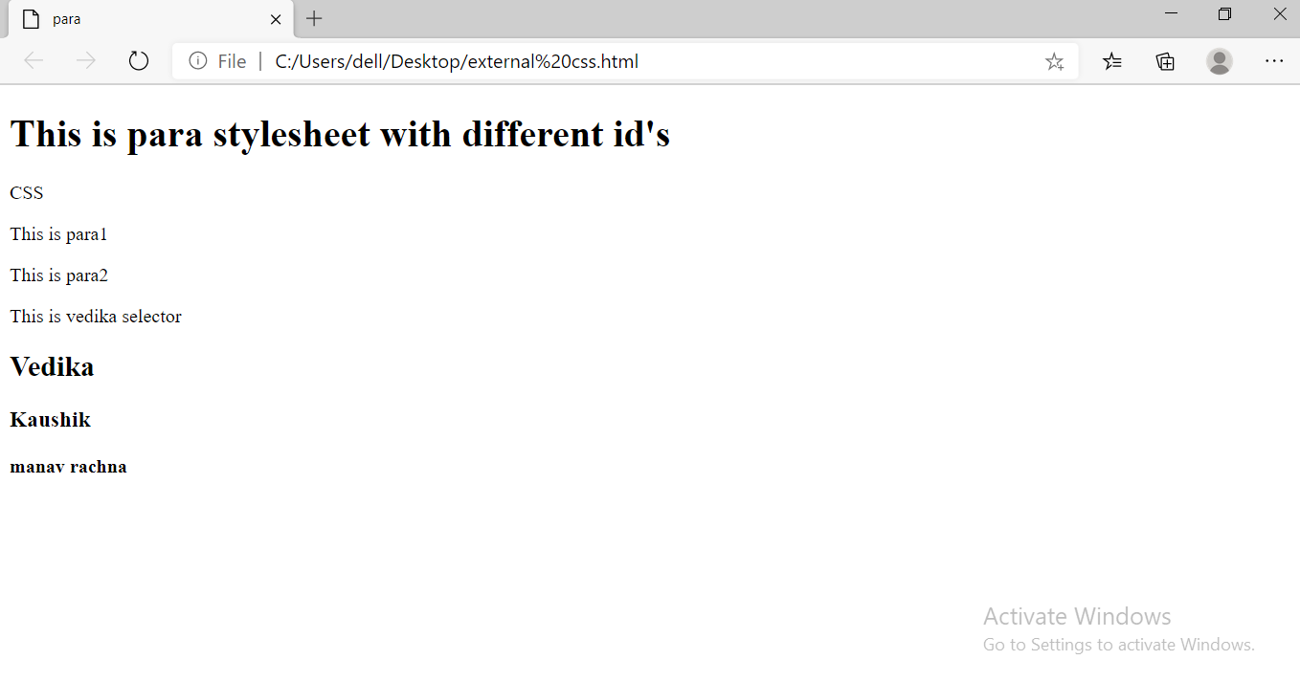

**Exercise-25**

**Write code to show Internal CSS with HTML code.**

<!DOCTYPE html>

<html>

<head>

<title>internal CSS</title>

<style>

body {background-color:red;}

p{color:white; font-size: 430%;}

h1{color:blue; font-size: 450%;}

h2{color:powderblue; font-size:400%}

</style>

</head>

<body>

<p> This paragraph for CSS</p>

<h1>html</h1>

<h2>CSS</h2>

</body>

</html>

**OUTPUT:**

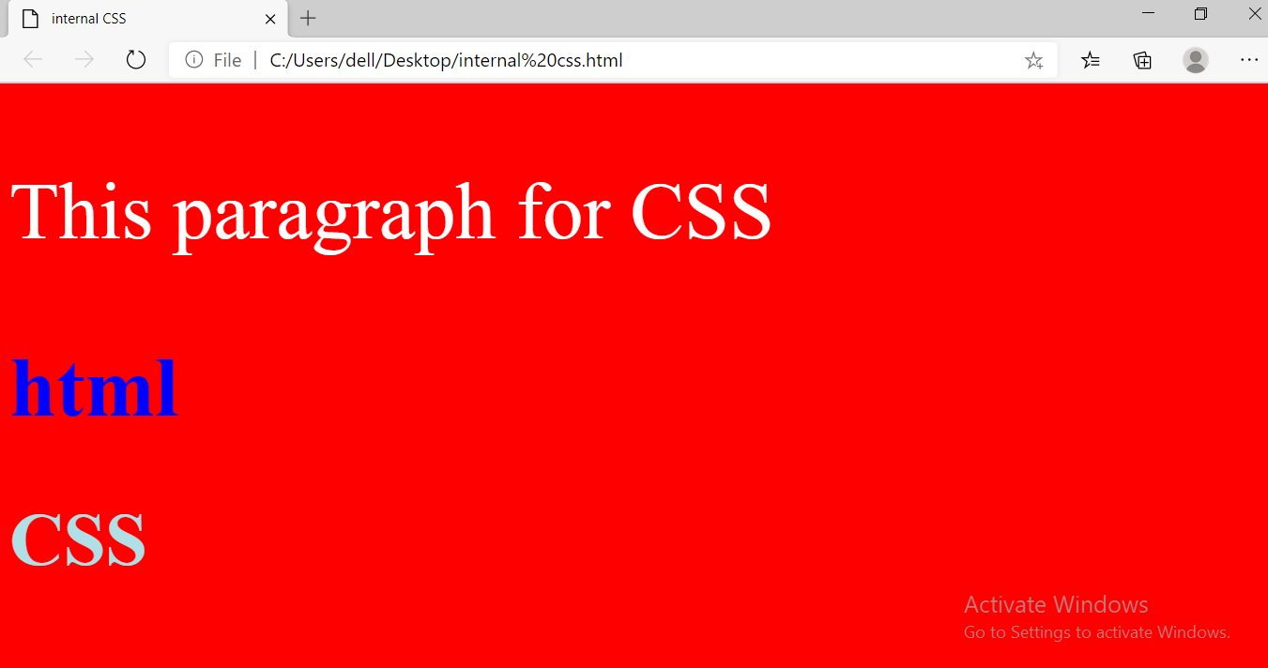

**Exercise-26**

**Write code to show inline CSS with HTML code.**

<!DOCTYPE html>

<html lang="en">

<head>

<title>Inline CSS Example</title>

</head>

<body>

<h1 style="color:blue;font-family:Arial,sans-serif,">Welcome to My Web Page</h1>

<p style="color:red; background-color:yellow; padding:10px;">This paragraph is styled using inline

CSS.</p>

</body>

</html>

**OUTPUT:**